**CASE STUDY - POWER BI**

**DATA LOADING**

* Tables creation in SSM

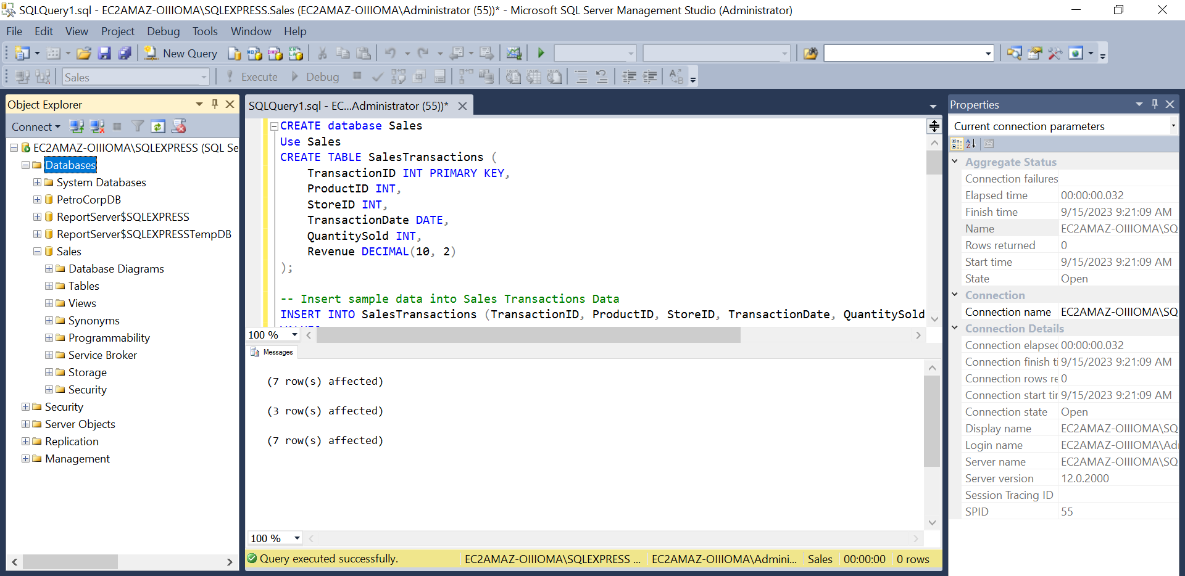

* Loading data into PowerBI

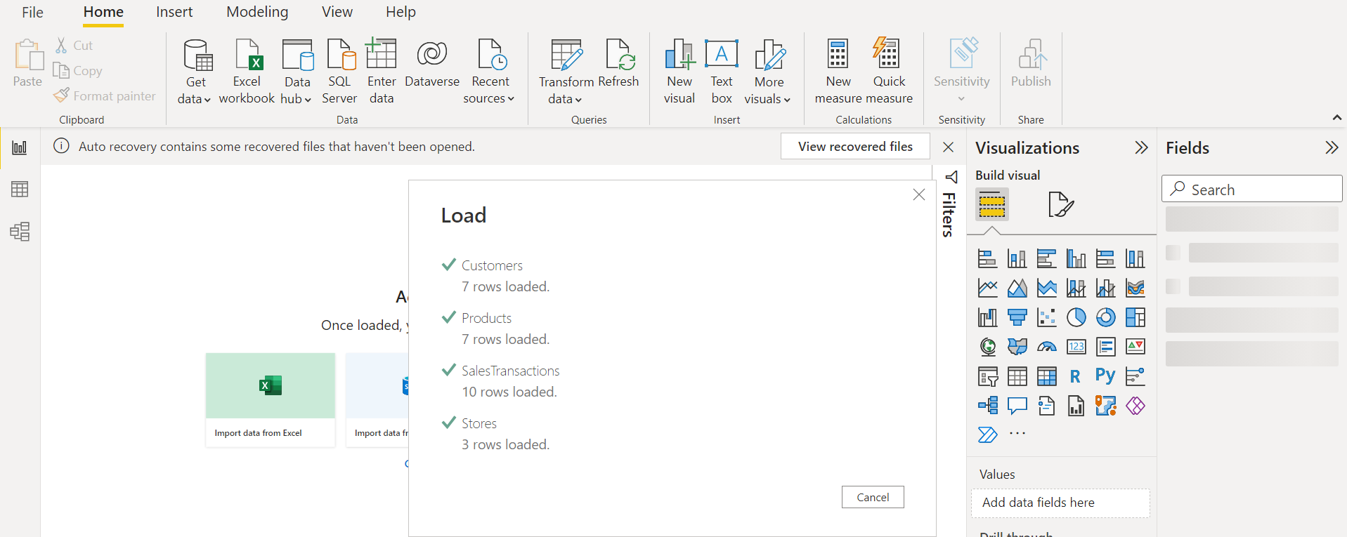

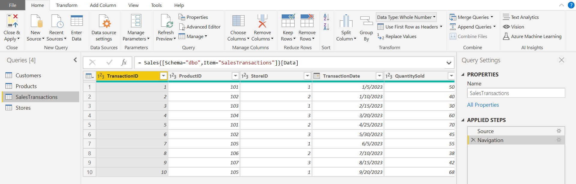

**DATA TRANSFORMATION**

* Merge Tables

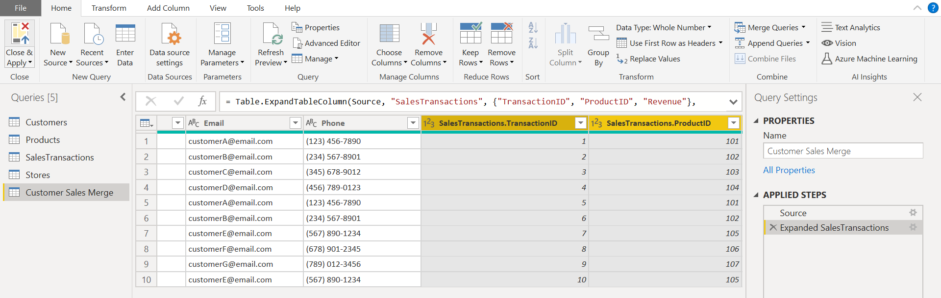

* Cleaning data

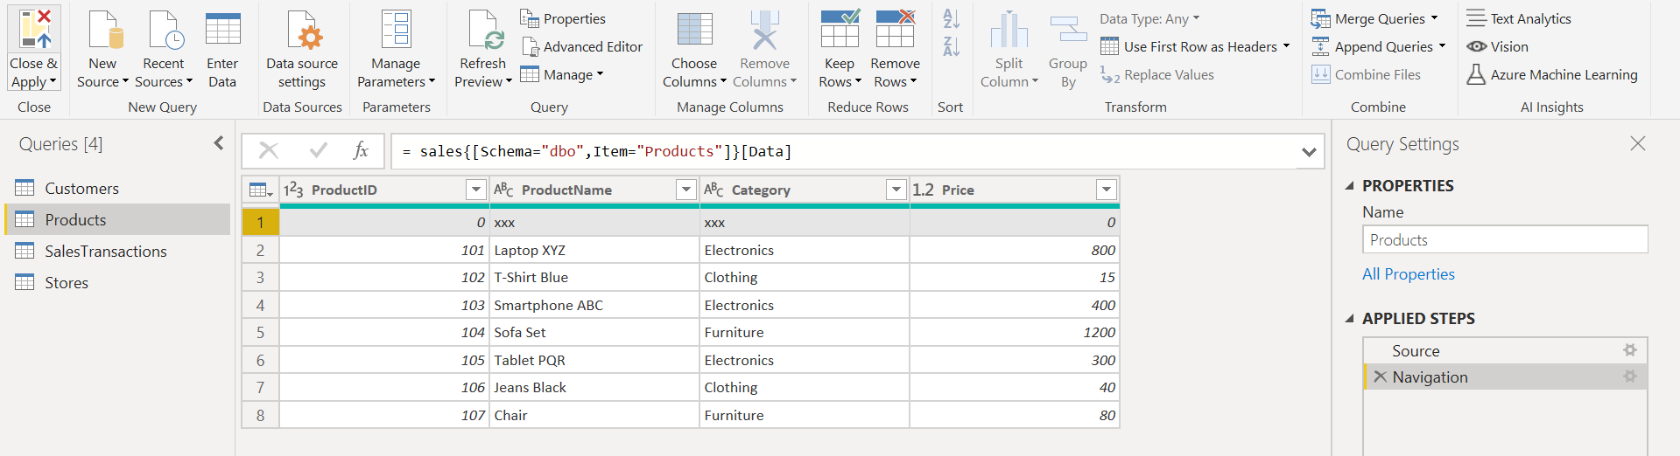

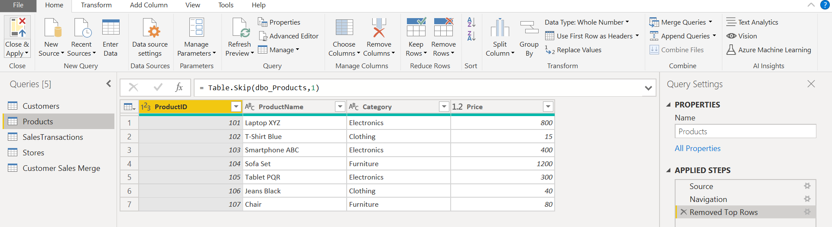

* Calculated Column

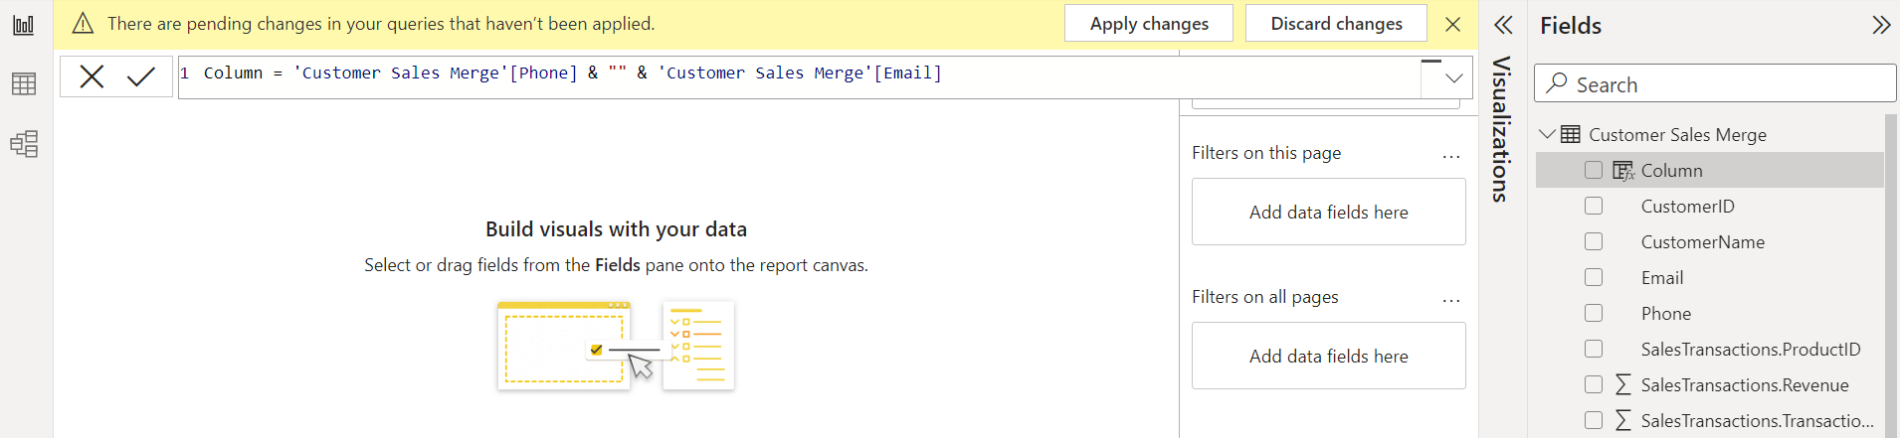

* Filter Data

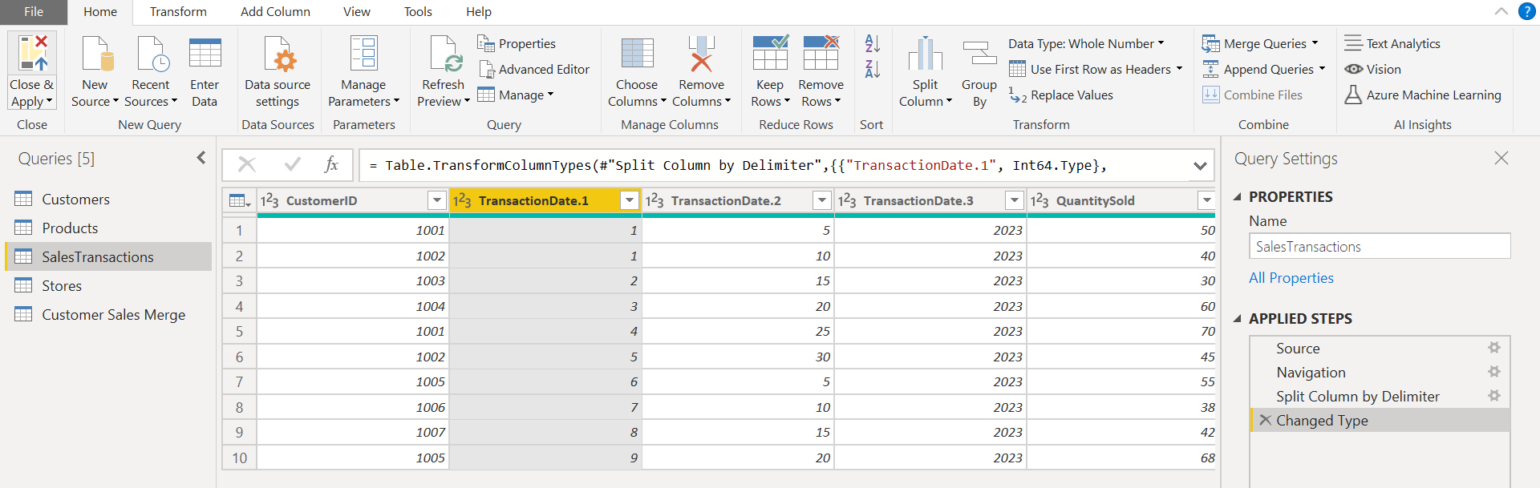

**DATA MODELLING**

* Create Relationships

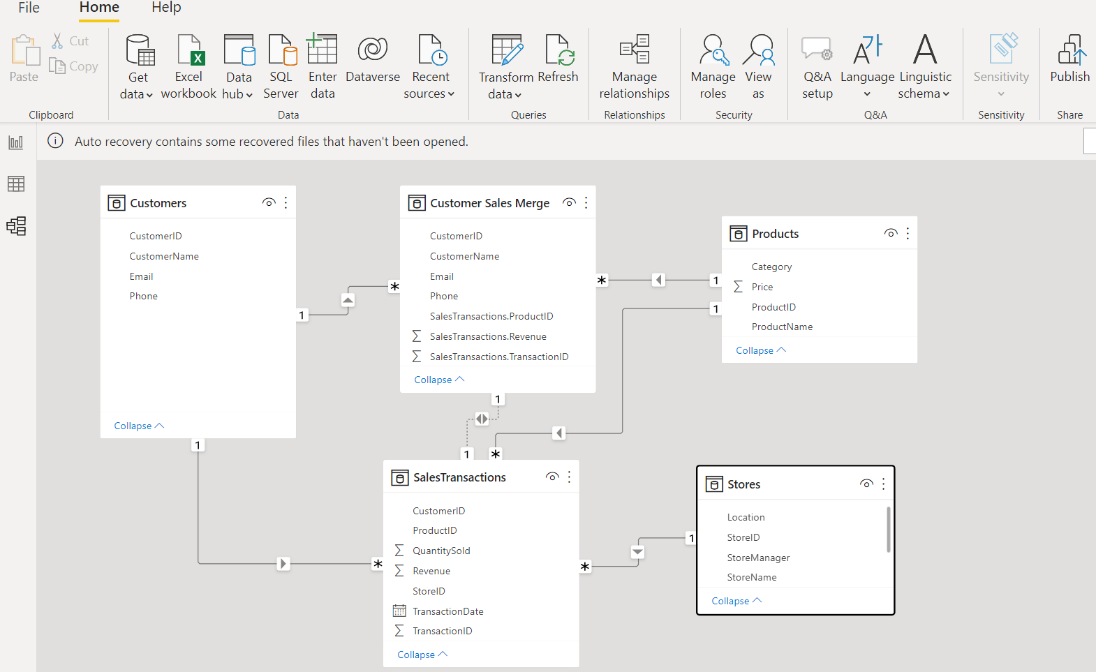

* Create Hierarchy

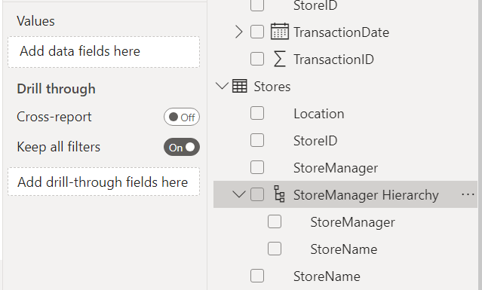

**BUSINESS QUERIES AND ANALYSIS**

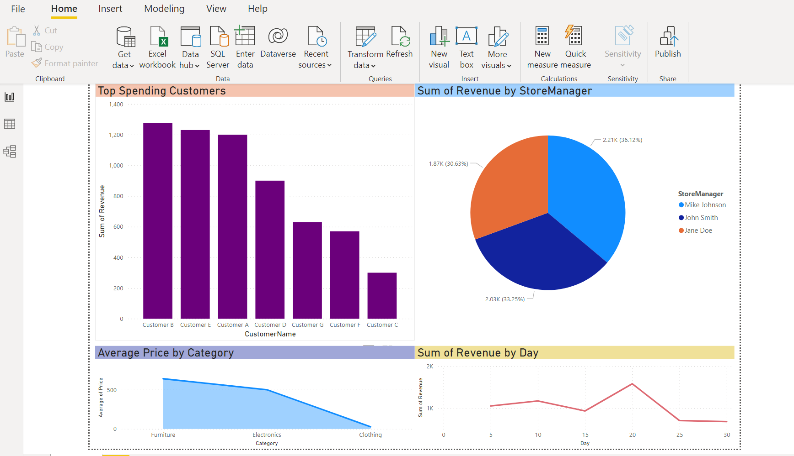

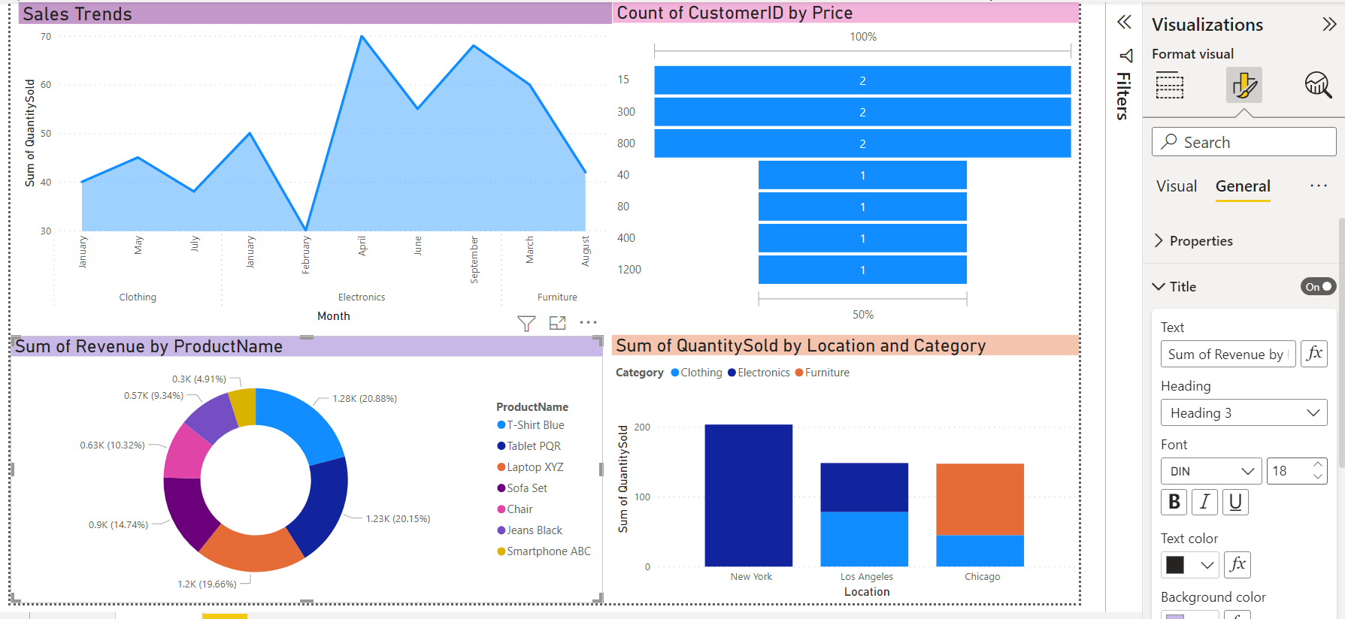

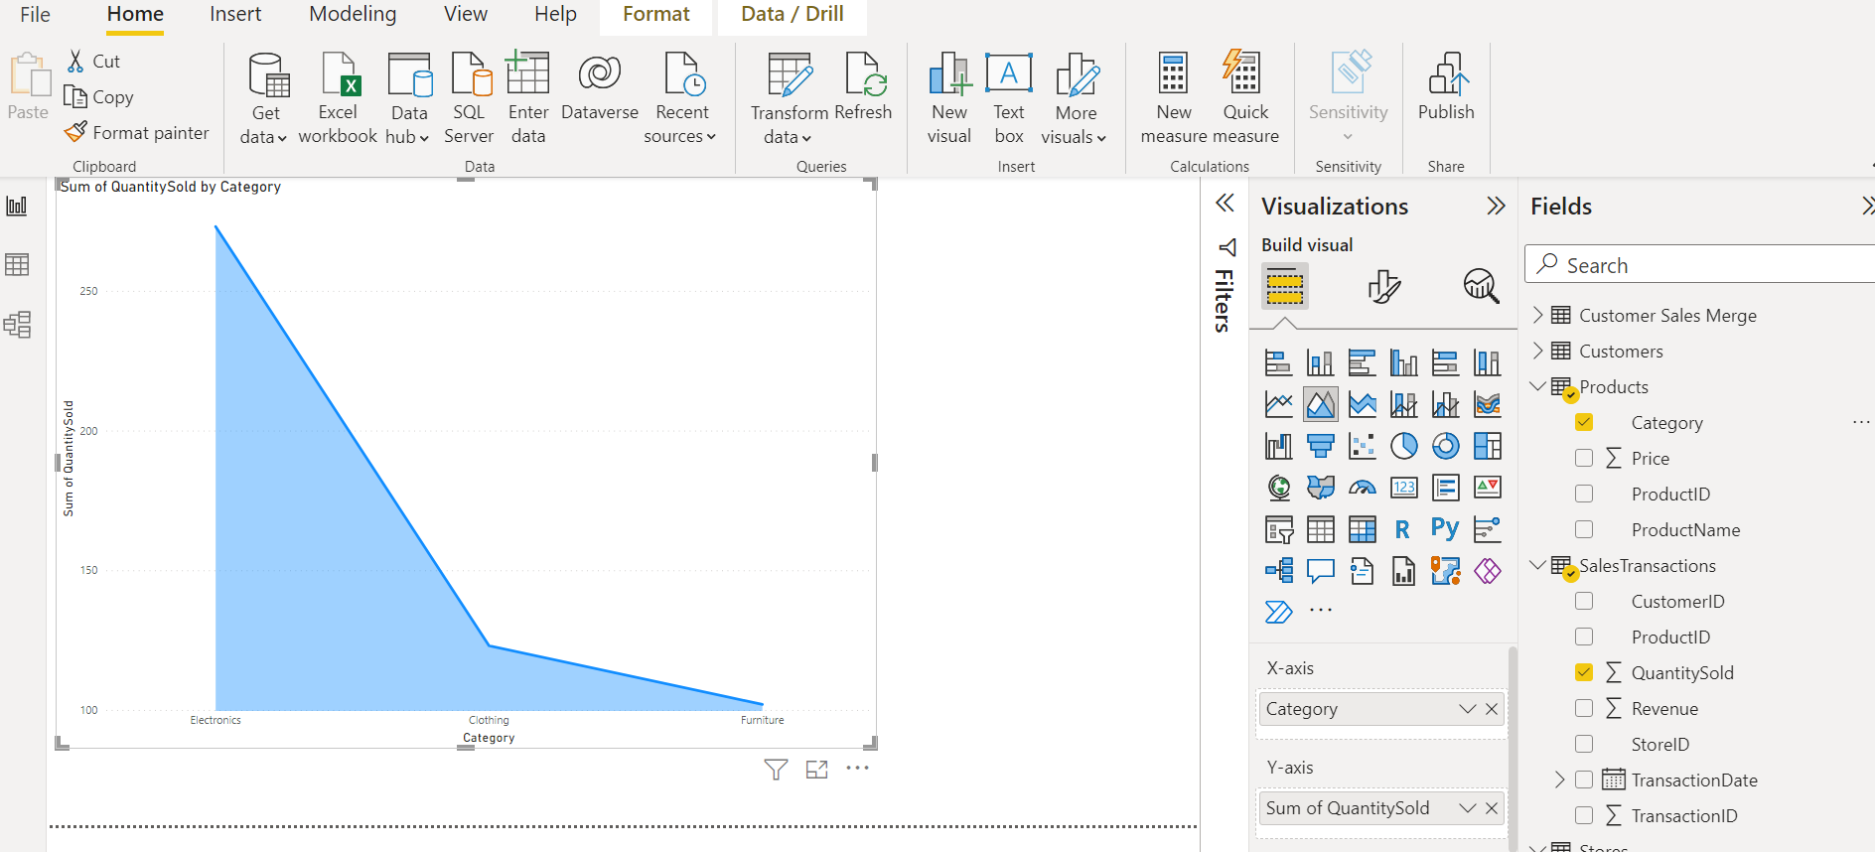

**BUSINESS INSIGHTS**

1. **Reward High-Spending Customers:** Identify top-spending customers like Customer B and consider sending them special promotional offers to encourage repeat purchases and increase overall revenue.

2. **Leverage 20th Day Spending:** Recognize that the 20th day of the month shows higher spending patterns. Plan sales or discount promotions before this date to capitalize on this trend and boost sales.

3. **Optimize Store Inventory:** Ensure that stores with higher customer footfall maintain well-stocked inventories to maximize revenue potential.

4. **Focus on Electronics Category:** Given the profitability of the 'Electronics' category, concentrate marketing efforts, and promotions on these products to drive higher sales and revenue.

5. **Time Promotions with Sales Peaks:** Align marketing campaigns with months when 'Electronics' sales tend to peak, increasing the likelihood of attracting more customers during these periods.

6. **Customer Feedback for Improvement:** Gather and analyze customer feedback to pinpoint areas where product quality, customer service, and the overall shopping experience can be enhanced.